FOCUSED SURVEY FACILITY WORKSHEET (MDS WORKSHEET #1) COMPLETION INSTRUCTIONS
Open the Focused Survey Facility Worksheet Template located on the ECC Compliance Website under survey.
Next, Go into Matrix and Run the Resident Bed Listing Report
LOG INTO MATRIX
Click on the facility tab and go to reports
Under Resident Information, Select the “Resident Bed Listing” Report
The following parameters should be followed:
[Grab your reader’s attention with a great quote from the document or use this space to emphasize a key point. To place this text box anywhere on the page, just drag it.]
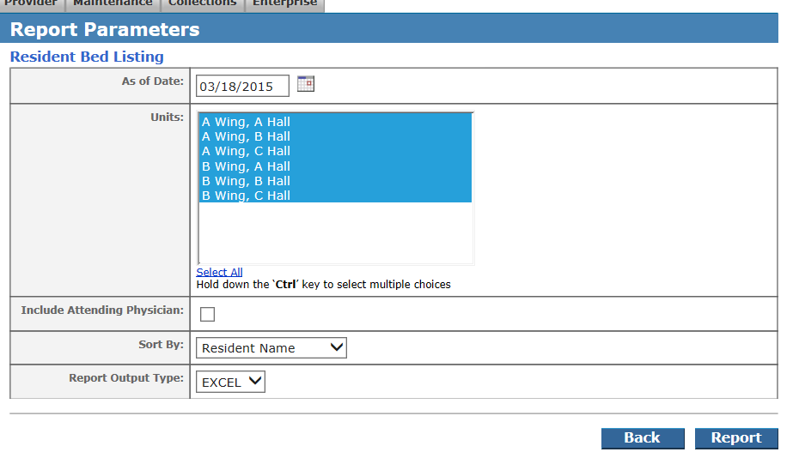
CHOOSE EXCEL
RESIDENT NAME
UNCHECK
SELECT ALL
TODAY’S DATE
After you have run the report, you will need to copy the first three columns from this report and paste them into the Focused Survey Facility Worksheet Template you opened in step one.
To copy the data, do the following:
A. FROM THE RESIDENT BED LISTING REPORT:
Place your curser in the A column of the first row of resident information
Highlight selecting a cell, holding down the mouse and moving the curser across column A, B and C and Highlight to the last row of resident information
Right Click on your mouse, after you have everything you need highlighted
Select Copy from the menu

B. GO TO THE FOCUSED SURVEY FACILITY WORKSHEET TEMPLATE:
Left Click on the cell right under the words Resident Room
Right Click in the same cell and select Paste from the menu

RESTRAINTS:
To get the list of residents with orders for restraints
LOG INTO MATRIX
Click on the facility tab and go to reports
Under the orders category select the “Order Report by Category” Report
Select the parameters below

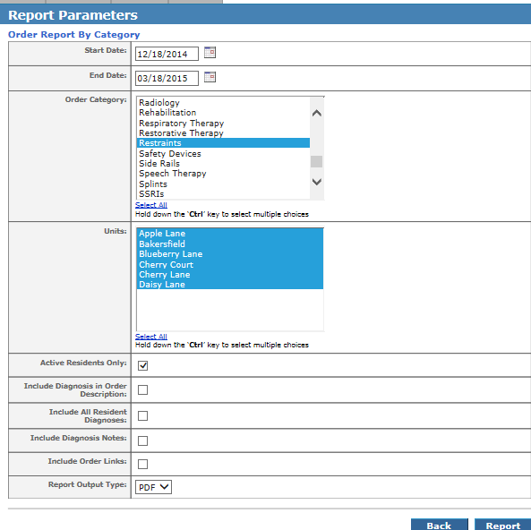
RUN THE REPORT
SELECT ALL UNITS
SELECT RESTRAINTS
BEGIN 90 DAYS BEFORE SURVEY DATE
FALLS WITH MAJOR INJURY
Login to QA Reader

On the menu bar to the left, select Reports
Select Logs
Go to the Falls area (second section)
Enter the beginning date of 90 days ago
Enter the end date of today
Run the report.

This repot will come up in excel. This report will contain all of the falls for your building in the last 90 days.
You will need to review to see if the fall has major injury or not and enter that on your Worksheet.
PRESSURE ULCER LIST
Use the last 90 days of Weekly Pressure Ulcer Reports to gather this information

URINARY CATHETERS
To get the list of residents with orders for Urinary Catheters
LOG INTO MATRIX
Click on the facility tab and go to reports
Under the orders category select the “Order Report by Category” Report
Select the parameters below

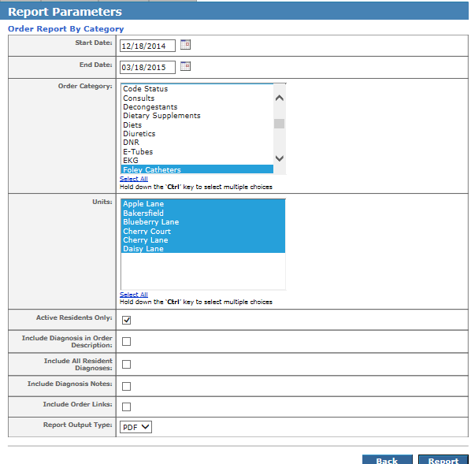
SELECT ALL UNITS
BEGIN 90 DAYS BEFORE SURVEY DATE
SELECT CATHETERS AND FOLEY CATHETERS
RUN THE REPORT
URINARY TRACT INFECTIONS

Use the last 90 days of Infection Control Reports from the ECC Clinical Reports system

ANTIPSYCHOTIC MEDICATIONS

To Get a list of all of the residents who had orders for Antipsychotic Medications in the last 90 days

LOG INTO MATRIX
Click on the Facility Tab and select Reports
Under the Orders Category, select the report “Resident Orders”

Below are the settings to be followed: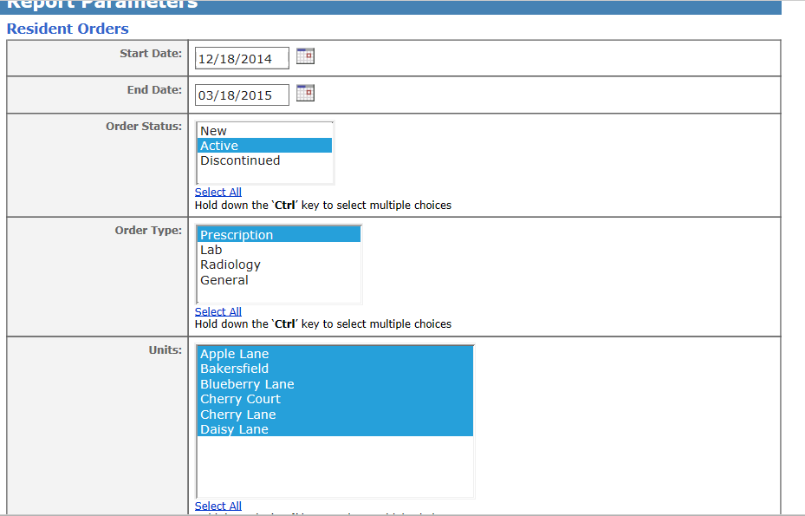 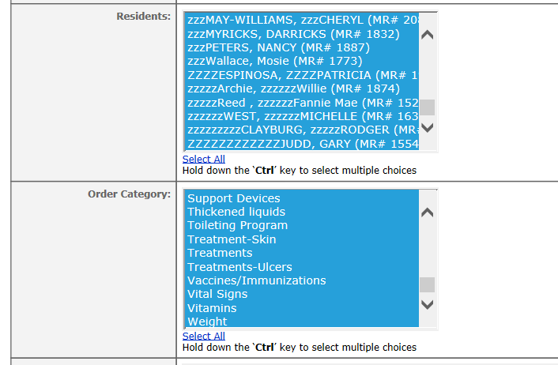 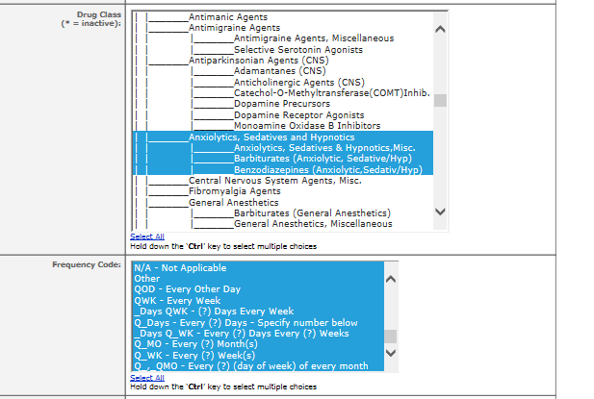
SELECT ALL CATEGORIES
SELECT ALL RESIDENTS
SELECT ALL UNITS
SELECT PRESCRIPTION
SELECT ACTIVE
BEGIN 90 DAYS BEFORE THE SURVEY DATE
SELECT ALL FREQUENCIES
SELECT ANXIOLYTICS, SEDATIVES AND HYPNOTICS AND THE THREE ITEMS BELOW THAT

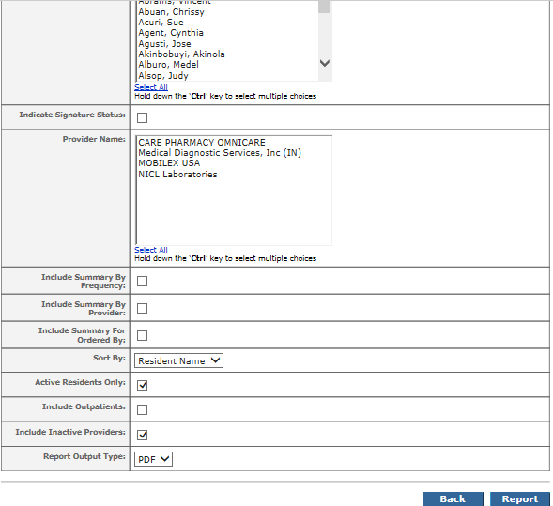
SELECT ALL PROVIDERS
SELECT ALL ORDERED BY
CLICK ON REPORT

EXTENSIVE ASSIST OF 2 OR MORE

To get a list of who scored on the MDS with an extensive assist of 2 or more,
LOG INTO MATRIX
Click on the facility tab and go to reports
Under the RAI Category, select MDS3.0 ADL Score Report
Select the parameters below

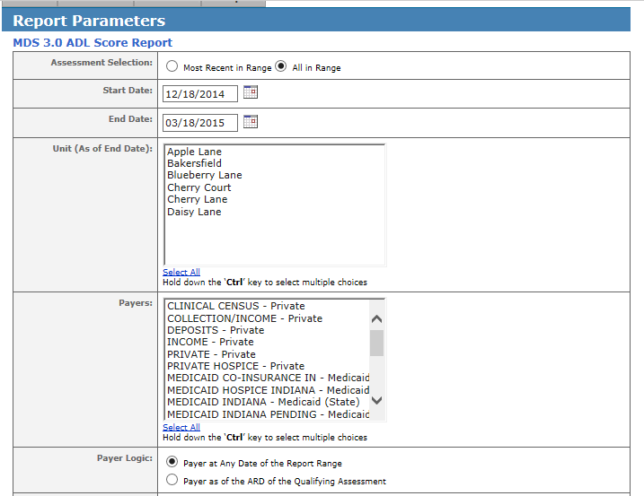
SELECT ALL PAYERS
SELECT ALL UNITS
SELECT 90 DAYS PRIOR FOR START DATE
SELECT ALL IN RANGE
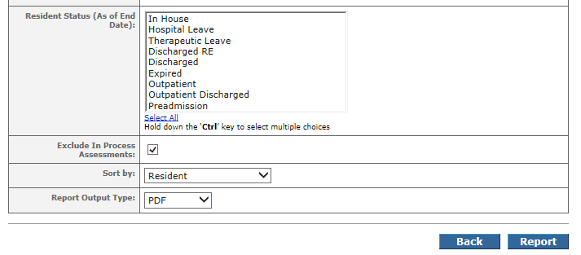
CLICK ON REPORT
SELECT IN HOUSE, HOSPITAL LEAVE AND THERAPEUTIC LEAVE

SKILLED AND LTC

This information will need to be filled in by the clinical team at the Building.

